Here are the basic definitions needed to perform nodal and mesh analysis.

1. Node—connection point of two or more circuit branches. The example circuit shown has five (5) nodes {V1, V2, V3, V4, Vref}

2. Reference Node—any node can serve as a reference node; however the node with the most branches connected is usually chosen for convenience. The reference (or ground) node was selected at the bottom of the circuit, and is identified by the small triangle symbol. Note that the reference node has four (4) circuit branches connected, while the other nodes have only three (3) branches connected.

3. Defined Node—any node which has a voltage source (i.e. battery) connected with respect to the reference node. In the circuit shown below, both nodes V1 and V4 are defined nodes. If fact, V1 = VB1 and V4 = VB2.

4. Undefined Node—any node where the voltage can’t be found by observation. In the example shown, nodes V2 and V3 are the undefined nodes. The number of undefined nodes will determine the number of linear equations which will need to be solved.

3. Ohm’s Law—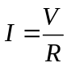

4. Kirchhoff’s Current Law—the sum of the currents entering a node is equal to the sum of the currents exiting the node.

5. Kirchhoff’s Voltage Law—the algebraic of the voltages around any closed loop (or mesh) is zero.

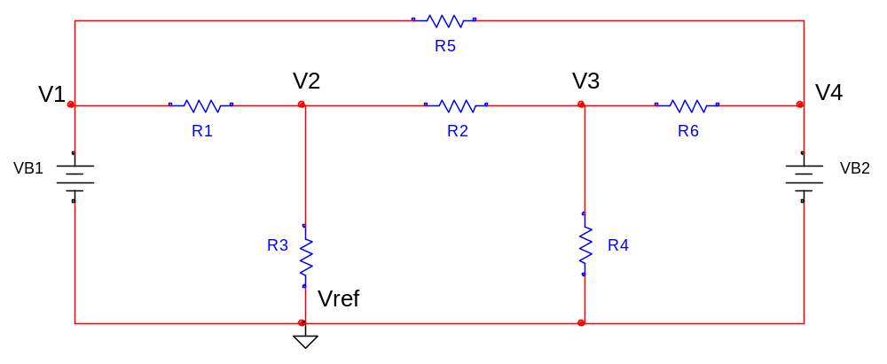

Nodal analysis procedure:

Step 1 Select and label a reference node (Note: Vref =0), then label all of the remaining nodes V1, V2, V3, ….

Step 2 Determine if any of the nodes are already defined, i.e. V1 = VB1, and V4 = VB2.

Step 3 Identify the currents in each of the resistor branches, and label, i1, i2, i3, …. The current direction (indicated by the arrows) is arbitrary; however, once the direction is selected it must remain unchanged throughout the analysis. A negative current simply means that the actual direction is opposite from the original direction chosen.

Step 4 Use Ohm’s Law to determine each of the branch currents:

Note: both battery voltages VB1 and VB2 are known values.

Step 5 Use Kirchhoff’s Current Law at each undefined node, i.e. at V2 and V3

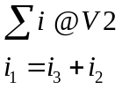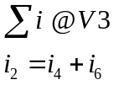

Step 6 Substitute the current expressions from Step 4 into the two nodal equations in Step 5, then arrange into standard form.

(I) 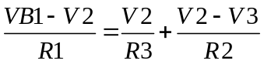 (II) 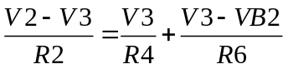
Carl, we usually substitute in the known component values at this stage of the solution, the known values are: VB1, VB2, R1, R2, R3, R4, R5, and R6. The two unknown values are the nodal voltages V2 and V3. I thought you might like to see the algebraic solution ☺

Finding the LCD we can simplify (I) as follows:

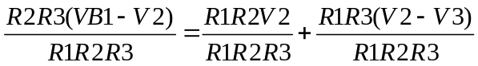

(III)

Similarly, we can simplify (II)

(IV)

Step 7 Finally, arrange into matrix form and solve.

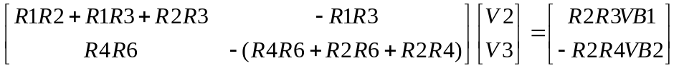

Step 8 Check using Tellegen’s Theorem

Tellegen’s Theorem basically states that the total power being delivered must be equal to the total power absorbed in the circuit….like conservation of energy!

So, if you make all of the resistors 1K and let VB1 =10 and VB2 =5, and solve for V2 and V3, you should get V2 = 4.375 volts and V3 = 3.125 volts.

I’ll show you how to calculate power next ☺

